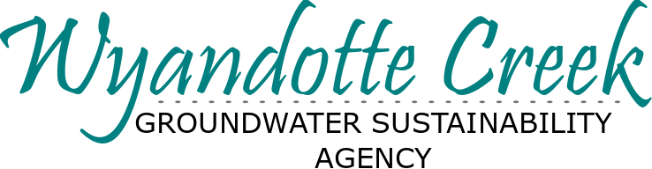
Draft Wyandotte Creek GSA
Groundwater Sustainability Plan - GSP
is Available for Public Review
The Wyandotte Creek Groundwater Sustainability Agency (GSA) is pleased to announce that the draft Groundwater Sustainability Plan (GSP) for the Wyandotte Creek Subbasin is available for public review and comment. Preparation of the GSP is a key milestone for implementing the state-mandated Sustainable Groundwater Management Act (SGMA).
The documents can be found online:
https://www.wyandottecreekgsa.com/draft-groundwater-sustainability-plan-gsp
The Public Comment Period ends October 24, 2021, 11:59 PM
Submit a comment through one of two methods:
- Submit multiple comments by email to WyandotteGSA@gmail.com. To better organize public comments, we are requesting that commenters use a comment tracking sheet. You can access the comment form and rename it with your name or entity abbreviation: Comment Tracking Sheet.xlsx. Compile your comments in the Excel table or any written format. Please reference your comment to the chapter and section of the GSP with line numbers to facilitate tracking of comments.
- Mail Comments to:
Butte County Department of Water & Resource Conservation
RE: Wyandotte Creek Subbasin GSP
308 Nelson Ave., Oroville, CA, 95965
Important Notes:
- You can submit multiple comments.
- Remember to submit comments by October 24, 2021, 11:59 p.m.
Visit https://www.wyandottecreekgsa.com/draft-groundwater-sustainability-plan-gsp
- We strongly encourage you to attend the Public Workshop on October 20, 2021.
- If you have trouble finding or accessing information listed here, please contact us at WyandotteGSA@gmail.com or visit our website https://www.wyandottecreekgsa.com/

Managing Groundwater in

the Wyandotte Creek Subbasin

Public Comment Period Open | Upcoming Public Meetings
Groundwater Sustainability Plan (GSP)

Draft GSP Public Comment Period
Visit
https://www.wyandottecreekgsa.com/
to view the draft GSP and learn how to submit comments.
Comments are due:
October 24, 2021

Public Workshop:
October 20, 2021
6:00-8:00pm
In-person:
HR Training Room East
3 County Center Dr.
Oroville, CA 95965
Online:
One-Click to Join: https://cbuilding.zoom.us/j/96698241765
or call in by phone: +1 669 900 6833
Meeting ID: 966 9824 1765
In response to the 2014 Sustainable Groundwater Management Act (SGMA), the GSP is a roadmap for how groundwater will be managed over the next two decades. The draft GSP is available for public review and comment through October 24, 2021.
Why do we need a plan?
While the Wyandotte Creek Subbasin is in healthy condition, extended drought and groundwater pumping can threaten the long-term future of groundwater needed to support our needs. The State requires local agencies to develop and adopt a GSP by January 2022. If the Wyandotte Creek Subbasin fails to meet state-mandated requirements, the State may intervene at a much higher cost than if we retain local control.
What is in the plan?
GSPs must assess groundwater conditions and articulate how groundwater management will avoid adverse impacts to beneficial users, including domestic, municipal, tribal, agricultural, industrial, and environmental uses.
GSPs include:
- Description of plan area and basin setting
- Current and historical data for six sustainability indicators
- Discussion of historical and projected water demands and supplies
- Figures with details of the subbasin
- Sustainability goal for a desired condition for the entire subbasin
- Minimum thresholds, measurable objectives and interim milestones (every
5-years), to maintain the sustainability goal over the planning horizon
- Projects and Management Actions for achieving and maintaining sustainability
- Implementation Plan including costs, schedule, monitoring, and reporting
Who is developing the GSP?
The GSP was developed with the support and input from subject matter experts, the Wyandotte Creek Advisory Committee, the Wyandotte Creek GSA Board and Member Agencies (County of Butte, City of Oroville, and Thermalito Water and Sewer District), and the community. Visit https://www.wyandottecreekgsa.com/ for more information or email WyandotteGSA@gmail.com.

