Wyandotte Creek Subbasin Advisory (WAC) Committee Correspondence
April 30, 2021

From: Nicole Johansson <nicole@lodestarfarms.com>
Sent: Thursday, April 22, 2021 12:04 PM
To: Peterson, Kelly <KPeterson@buttecounty.net>
Subject: National Ag Water Coalition Highlights Need for More Water Investments in Biden Infrastructure Proposal | And Now U Know

. | ATTENTION: This message originated from outside Butte County. Please exercise judgment before opening attachments, clicking on links, or replying. | .

From an agriculture perspective, storage is a big issue nationally. As I mentioned on the phone the farmers are advocating for storage. This is at the federal level. I’m not sure if we want to bring up the topic of water storage on the local level but I do see that while it can be political in nature, in the future storage is going to be important.

Thank you,
Nicole

https://www.andnowuknow.com/behind-greens/national-ag-water-coalition-highlights-need-more-water-investments-biden-Jamie-Johansson-Dave-Puglia-Dan-Keppen-David-Reynolds-Christine-Arbograst/jenna-plasterer/72762

National Ag Water Coalition Highlights Need for More Water Investments in Biden Infrastructure Proposal
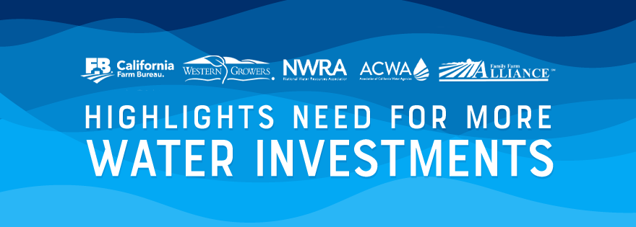
IRVINE, CA - Several industry leaders have come together to form a national coalition of over 200 agricultural organizations along with urban and rural water districts. Commenting on the conservation, efficiency, recycling, and watershed management initiatives in the Biden administration’s initial infrastructure proposal, the coalition urges the federal government to further bolster investments in the nation’s aging water facilities.
Dave Puglia, President and Chief Executive Officer, Western Growers Association“Decades of neglect have rendered our federal water projects unable to meet the human and environmental needs of the West,” Western Growers President and CEO Dave Puglia said. “While highways and bridges are front and center in the administration’s proposal, federal investments in water storage and conveyance would present an opportunity to strengthen our farming and rural communities while providing good-paying jobs and an economic boon for the construction industry.”
In January, the coalition called on the administration and congressional leaders to invest in a diversified water management portfolio that enhances water supply and quality for urban and environmental uses, while maintaining water flowing to Western farms and rural communities.
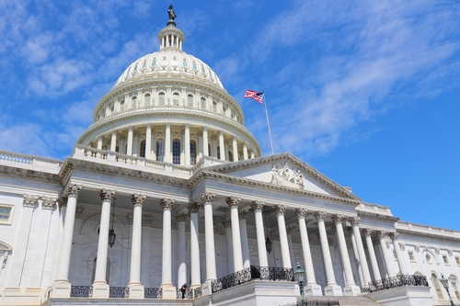Commenting on the conservation, efficiency, recycling, and watershed management initiatives in the Biden administration’s initial infrastructure proposal, the coalition urges the federal government to further bolster investments in the nation’s aging water facilities
While the details of the plan are still forthcoming, the coalition said it looks forward to working with the administration and Congress on the larger need for Western water infrastructure, such as above- and below-ground water storage facilities, conveyance and desalination, along with federal financing mechanisms for such water projects.
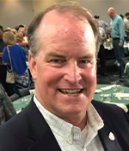Jamie Johansson, President, California Farm Bureau Federation“To ensure that food can continue to be safely and affordably produced in the West, and that rural communities continue to have access to the water critical to their economies, it is important that water supply investment be included as a necessary component of a national infrastructure package,” California Farm Bureau President Jamie Johansson said. “We will continue to work with Congressional leaders to build on the administration proposal with enhanced funding for water infrastructure.”
With Western states facing another drought despite their importance in supplying much of the nation’s food supply, the coalition said it is even more critical to recognize the need for rural water infrastructure investments to capture and store water for use when it is needed most.
Dan Keppen, Executive Director, Family Farm Alliance“The severe drought punishing much of the West only emphasizes the need to plan now for future droughts and provide the funding needed to not only fix, but to ‘build back better’ the national system responsible for delivering water to homes, businesses, farms, and the environment,” Family Farm Alliance Executive Director Dan Keppen said.
According to a press release, the coalition includes organizations from 15 states that collectively represent $120 billion in agricultural production, nearly one-third of all agricultural production in the country, and tens of millions of urban and rural water users.
“Appropriate investments in water infrastructure will assure that underserved rural communities throughout the nation have access to clean, reliable water,” Association of California Water Agencies Director of Federal Relations David Reynolds said. “Water infrastructure funding can help the nation adjust to climate change, better protect the environment, and help ensure safe, abundant, local food supplies.”
National Water Resources Association President Christine Arbogast, also commented on this initiative.
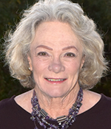Christine Arbogast, President, National Water Resources Association (Photo Credit: Municipal Water Leader)“The Biden administration has put its opening hand in the infrastructure debate on the table,” Arbogast said. “We look forward to additional details and discussion on the Western water and rural water elements specifically mentioned in the President’s Build Back Better proposal. Infrastructure needs in the West are different from other regions of the country, and they deserve the attention and investment which will come from the vigorous debate, which will now begin in earnest. We look forward to working with the administration and Congress on this critical effort.”
As more federal updates in regards to the agricultural industry come across our desks, you can count onAndNowUKnow to keep you in the loop.
Association of California Water Agencies
From: Nicole Johansson <nicole@lodestarfarms.com>
Sent: Thursday, April 22, 2021 12:06 PM
To: Peterson, Kelly <KPeterson@buttecounty.net>
Subject: 5 Things You Need to Know About Federal Drought Aid in California | Lost Coast Outpost | Humboldt County News

. | ATTENTION: This message originated from outside Butte County. Please exercise judgment before opening attachments, clicking on links, or replying. | .
Another though while I’m not sure it is relevant to groundwater specifically. Do we need to consider the role of water in fighting wild fires? If we are in a drought, how much water is being used to fight fires? Are we accounting for that usage, is there a PMA that could address fire mitigation and water transfers in a disaster?

Again, just thoughts for your consideration. I have thick skin and if these topics aren’t relevant, that is fine too!

Thanks,
Nicole

https://lostcoastoutpost.com/2021/apr/15/5-things-you-need-to-know-about-federal-drought-ai/

5 Things You Need to Know About Federal Drought Aid in California

Agricultural land near Adin, a small town in Modoc County, is irrigated in July 2019. The USDA declared a natural disaster in California due to the drought, which means farms become eligible for loans. Photo by Anne Wernikoff, CalMatters
###
Stop if you’ve heard this before: California is in the grip of a severe drought. Again.
Now the federal government is stepping in to help.
To assist California, which is the nation’s largest food supplier, the U.S. Department of Agriculture recently declared a drought disaster for 50 counties. That makes growers throughout the state who have been struggling with parched conditions eligible to seek federal loans.
“This declaration emphasizes the devastating and far-reaching impact of climate change on the agricultural producers that feed and power America,” Under Secretary of Agriculture Gloria Montaño Greene said in an emailed statement.
Here’s what you need to know about the disaster declaration and its effect on California:

There’s a big difference between a drought emergency and a USDA disaster
In March, U.S. Secretary of Agriculture Thomas Vilsack wrote to California Gov. Gavin Newsom designating 50 California counties as “primary natural disaster areas” due to drought.
A drought disaster sounds alarming, but officials say the reality is more mundane: It simply opens up emergency federal loans to California farmers who are struggling with back-to-back dry years. Growers in the 50 counties but also in all the counties next door (including 16 in Oregon, Arizona and Nevada) are eligible for loans.
“The bar is set very low to qualify, because the purpose of the disaster designation is to quickly make financial assistance available to (agricultural) producers,” said Jeanine Jones, interstate resources manager with the California Department of Water Resources.
This federal designation is very different from declaring a drought emergency under California’s Emergency Services Act, which would allow the governor to take more sweeping actions affecting all Californians, such as mandating conservation, waiving some state regulations and reallocating funds. Under state law, declaring a drought emergency would require “conditions of disaster or of extreme peril to the safety of persons and property within the state” that local governments can’t cope with on their own.
Comparing Vilsack’s designation of drought disaster areas to a state drought emergency is “like (comparing) apples to pineapples, because it’s a really large difference,” Jones said.

The decision was ‘as close to automatic as it can get’
So what is the federal decision based on? The USDA looks at how dehydrated California has been.
Rain and snow in much of the state are roughly half of average. The state deemed the snowpack on California’s mountains “well below normal.” The two major reservoirs are at about half of their capacity. And streamflow rivals levels during the peak of the last drought, which started in 2012 and continued through 2016.
“Much of the state has had two pretty darn dry years,” Jones said, adding that the most recent wet season — last October through March — ranks as the fourth driest on record in California.
A nationwide wetness watchdog, called the US Drought Monitor, has colored California in shades of yellow, orange, red and brown, which denote conditions ranging from abnormally dry to exceptional drought.
The USDA’s designations hinge on that map. Counties can be considered drought disaster areas if any part enters the driest red and brown “extreme” and “exceptional” categories during the growing season, or if they move into the orange “severe drought” category and stay there for eight consecutive weeks.
These categories are based on various measurements, not just precipitation and snowpack. They include vegetation health, soil moisture, surface water and other criteria. The map authors also work with local experts to gauge on-the-ground conditions.
“The disaster declaration process is almost as close to automatic as it can get” because it’s based on the drought map, said Jacque Johnson, acting state executive director of the USDA Farm Service Agency’s state office. “What happened in California on March 5 was 50 of our 58 counties were disasters.”

Vilsack’s letter designated 50 California counties as primary disaster areas. The other eight are listed as “contiguous” counties. What gives?
Contiguous counties are exactly what they sound like: the counties that didn’t quite hit the drought threshold at the time but are adjacent to primary disaster areas. The eight counties are Orange, San Diego, Ventura, Santa Barbara, San Luis Obispo, Monterey, Santa Cruz and San Benito. None of them, at the time of the declaration in March, had entered the more severe dry conditions of the other 50.
Growers throughout the state are eligible to apply for emergency federal loans until early November. Some also may qualify for other federal assistance programs.
“The assumption is that collateral damage falls into the next door neighbor county,” Johnson said. “The county line is not a barrier.”

Legislators are pressuring Newsom to declare emergency
Newsom has so far resisted calls to declare a drought emergency. He said on Tuesday that his staff had been “talking for months internally” and drought plans were in place, but he was opaque when it came to providing specifics.
“We are prepared to move very quickly when we are prepared to move,” Newsom said.
Officials have said that they believe the state has enough administrative tools to respond to the drought without declaring an emergency.
The governor, under the threat of a recall, may be in triage mode, taking his pick of emergencies to respond to: drought, predictions of another monster wildfire season and the ever-present global pandemic.
Lawmakers have been quick to pounce on what they see as Newsom’s inattention or indifference to a pressing problem that hits rural communities hard. A bipartisan group of legislators, led by Senate Agriculture Committee Chair Andreas Borgeas, a Republican from Fresno, and Assembly Agriculture Committee Chair Robert Rivas, a Democrat from Hollister, requested a statewide drought emergency declaration.
“From the Oregon border to the Mexican border, California farmers will see sharp cuts in water supplies this year.”
— Jamie Johansson, president of the California Farm Bureau
The legislators noted that allocations from the State Water Project, which draws water from the San Francisco Bay-Delta and sends it to cities and farms, have been reduced to 5% of normal. They urged the governor to forestall a catastrophic loss in farm revenue.
In a reference sure to get under Newsom’s skin, the letter referred to actions taken by former Gov. Jerry Brown in 2014 when similar drought conditions prevailed. That emergency declaration, the letter said, provided “flexibility and commonsense streamlining to utilize our limited water in the most efficient way.”
At that time, Brown issued conservation mandates for all state agencies and told local water agencies to immediately implement their water shortage contingency plans, which restricted residential water use. The declaration also modified reservoir releases, accelerated funding for water projects ready to break ground and lifted requirements that water projects comply with California’s environmental quality law.

The loans can make or break farms and ranches
The State Water Resources Control Board in March put California’s 69,000 farms on notice that they should start planning now for severe impacts this summer.
This comes after climate change and inadequate water supply are already battering California’s growers, who produce more than 400 commodities, worth nearly $50 billion a year, including about half of the nation’s fruits and vegetables and nearly a fifth of its milk.
Legislators estimate that about 1 million acres of San Joaquin Valley farmland will be fallowed over the next two to three decades because of reduced groundwater and surface water supplies. They project the loss of 85,000 jobs as a direct result of reduced water access.
Against that backdrop of dire news, the federal disaster declaration opens up aid for the state’s beleaguered growers and ranchers. The loans assist them for loss of crops, trees, land and livestock.
Each farm operation could receive a loan of up to $500,000, based on its loss. The USDA’s emergency loans were budgeted at $1.21 billion nationwide for this year.
The federal agency “considers each emergency loan application on its own merits, taking into account the extent of production losses on the farm and the security and repayment ability of the operator,” Vilsack told Newsom in his letter.

Agricultural land near Adin, a small town in Modoc County, is irrigated in July 2019. The USDA declared a natural disaster in California due to the drought, which means farms become eligible for loans. Photo by Anne Wernikoff, CalMatters
For farmers, the loans can make or break their operations, which are already on tight water allocation budgets.
“From the Oregon border to the Mexican border, California farmers will see sharp cuts in water supplies this year,” said Jamie Johansson, president of the California Farm Bureau. “That means hundreds of thousands of acres of land will lie idle. It means thousands of people will lose jobs, in both rural and urban areas. It means Californians will have less locally grown food available.”
The expenses can pile up. Because of the drought, ranchers may have to lease additional pasture, buy extra feed and pay to haul and store water to replace the natural water sources that have dried up, Johnson said.
The USDA has already received inquiries from California cattle ranchers interested in applying for the loans.
The state has about 13,000 cattle operations, with more than 5 million cattle and calves. The San Joaquin Valley, particularly Tulare, Merced and Kings counties, has the most.
Katie Roberti, a spokeswoman for the California Cattlemen’s Association, said ranchers are facing the most severe conditions in decades, worse than the last drought.
“While the federal designation is welcomed assistance, without precipitation many California cattle producers are going to be forced to make the difficult decision to reduce the size of their herds, some more drastically than others,” she said. “Feed on rangelands will be limited and we are hearing hay prices will be high. These herd reductions will have a lasting impact on the number of cattle in the West for years to come.”
###
CALmatters.org is a nonprofit, nonpartisan media venture explaining California policies and politics.

From: Nicole Johansson <nicole@lodestarfarms.com>
Sent: Thursday, April 22, 2021 12:17 PM
To: Peterson, Kelly <KPeterson@buttecounty.net>
Subject: Modesto Subbasin GSP

. | ATTENTION: This message originated from outside Butte County. Please exercise judgment before opening attachments, clicking on links, or replying. | .
Hi Kelly,

I thought we might see what other GSAs are doing so as to not have to re-invent the wheel entirely on our PMAs. There are some good ones in this plan. I thought the recycled water was especially interesting. This is the plan that’s already being reviewed by the state from the Modesto Basin. Some of the stuff is applicable, some is not.

Thanks,
Nicole

https://www.strgba.org/Content/Documents/Documents/Draft Groundwater Sustainability Plan.pdf

